**Misr International University**

**Course Code & Title: SWE320 Software Engineering**

**Semester: Fall 2025**

**Lab manual 1 - PHP**

Setting Up PHP on your pc:

* You need to find a webhost to supporting PHP and MYSQL . We will use local host on the computer to connect with PHP. You can choose between:

1. WAMP :supports windows operating system only
2. XAMPP: supports several operating systems
3. LAMP: supports linux operating system

* We will use XAMPP in this lab manual.

Download and install XAMPP:

1. Google Xampp and Download the latest version <https://www.apachefriends.org/download.html>

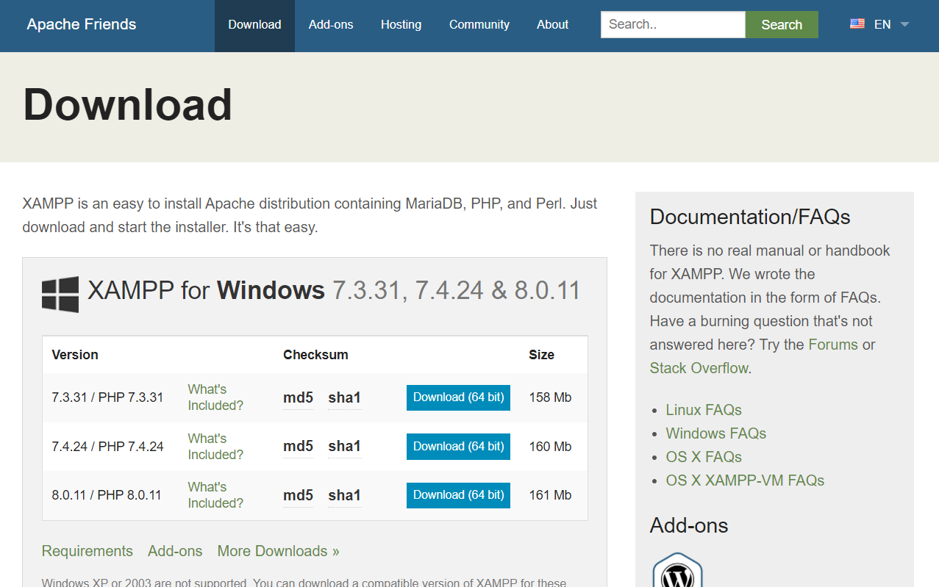

1. After installing it with default settings, this control panel will appear when you open it

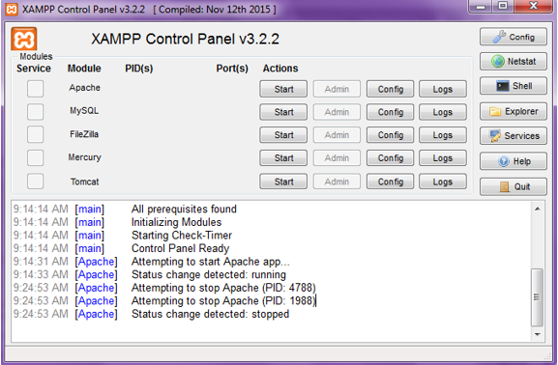

1. You have to start your APACHE service so the web Browser can access your PHP code and execute it . When it Activated the it’s status will be changed to GREEN color

C:\Users\instructor242\AppData\Local\Microsoft\Windows\INetCache\Content.MSO\9846EAC7.tmp

1. After installing your local host by default settings, a folder called “xampp” will be created in your C folder on your PC , place the folder of your project in the following directory:

C:\xampp\htdocs

1. In order to preview any file on your browser , you need to write the following directory in your web address bar in the web browser :

[http://localhost:8080/ProjectFolderName/Filename.php](http://localhost/ProjectFolderName/Filename.php)

**PHP Syntax**

* The default file extension for PHP files is ".php"
* A PHP script can be placed anywhere in the document.
* A PHP script starts with <?php and ends with ?>

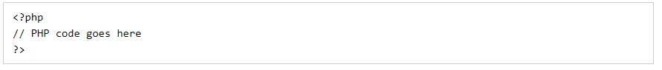

**Comments:**

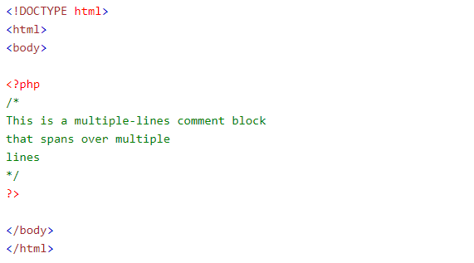

**Variables:**

Rules for PHP variables:

* A variable starts with the $ sign, followed by the name of the variable
* A variable name must start with a letter or the underscore character
* A variable name cannot start with a number
* A variable name can only contain alpha-numeric characters and underscores (A-z, 0-9, and _ )
* Variable names are case-sensitive ($age and $AGE are two different variables)

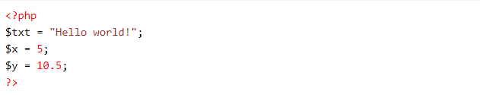

**The PHP echo Statement:**

* Output text with the echo command (notice that the text can contain HTML)

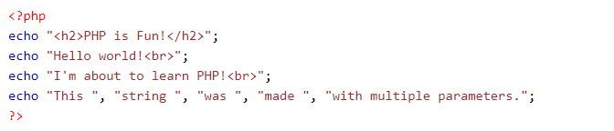

Output:

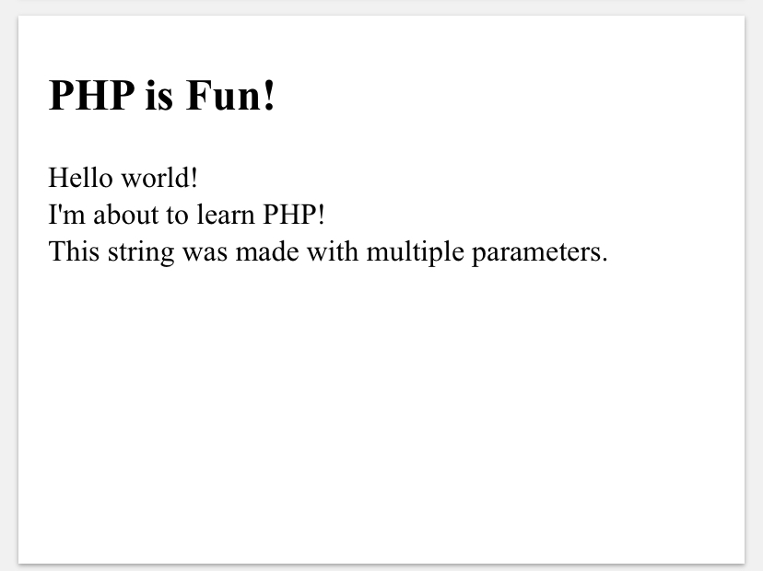

* output text and variables

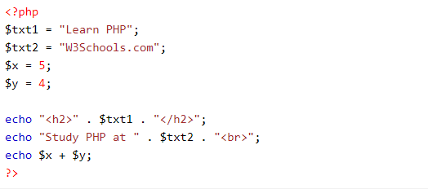

Output:



* *PHP String Functions:*

1. *Return the Length of a String --> strlen()*

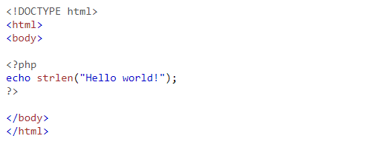

*Output :* 12

1. *Count Words in a String--> str_word_count()*

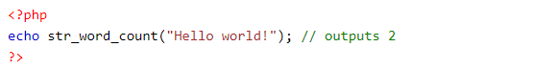

1. *Reverse a String--> strrev()*

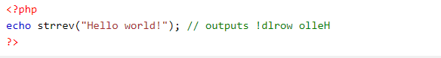

1. *Search For a Text Within a String-->strpos()*

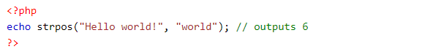

1. *Replace Text Within a String--> str_replace()*

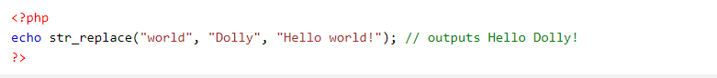

* *“Var_dump” returns the data type*

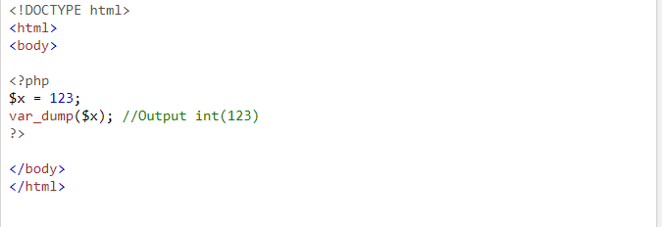

* *PHP Array*

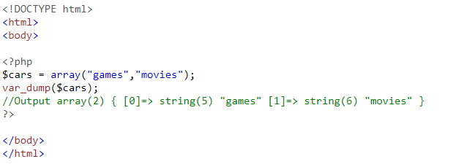

* *PHP NULL Value*

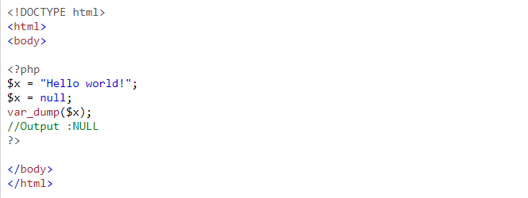

**Operators:**

* *Arithmetic*

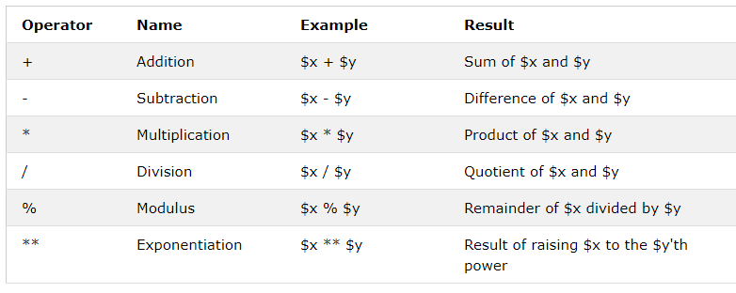

* *Assignment*

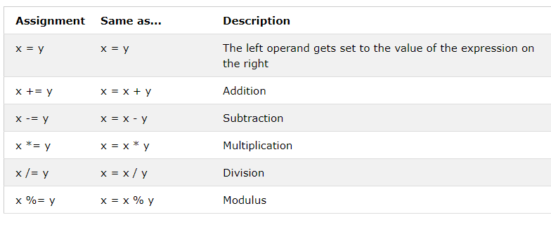

* *Comparison*

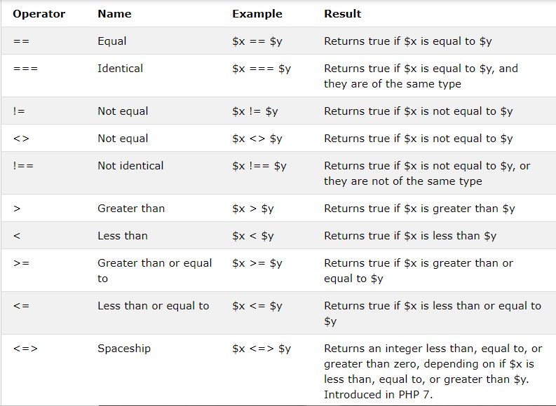

* *Increment / Decrement Operators*

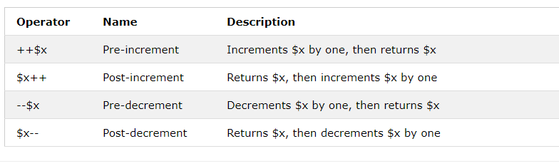

* *Logical Operators*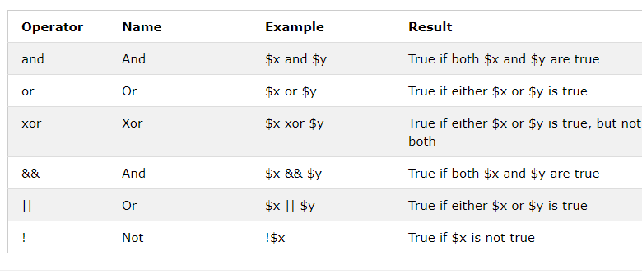

* *String Operators*

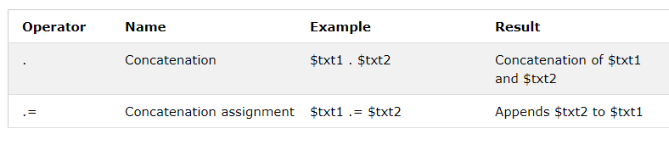

**If Conditions:**

* *Syntax:*

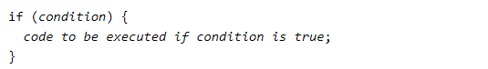

* *Example:*

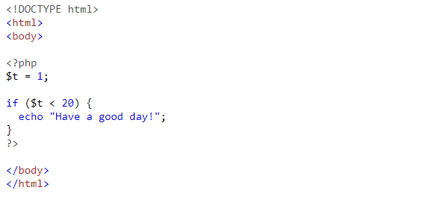

**Switch Cases:**

* *Syntax:*

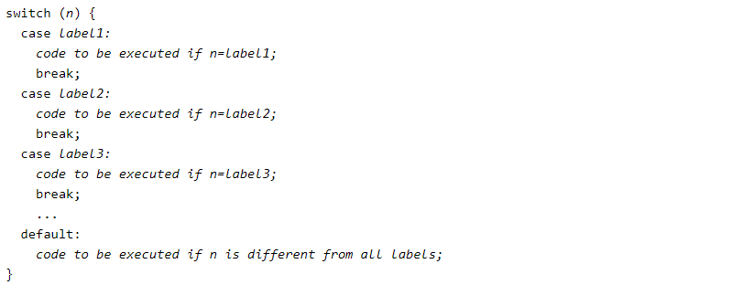

* *Example:*

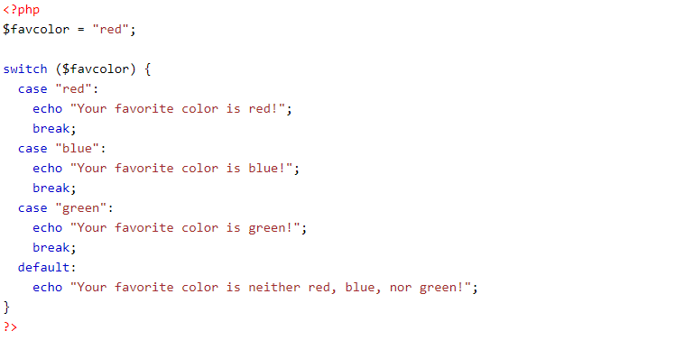

**Loops:**

* *While*

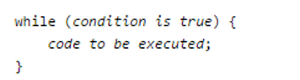

* *Do While*

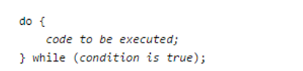

* *For Loop*

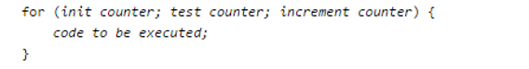

* *For Each*

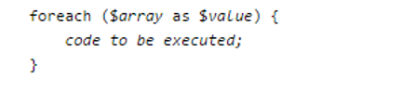

**Functions :**

* Besides the built-in PHP functions, it is possible to create your own functions.
* A function is a block of statements that can be used repeatedly in a program.
* A function will not execute automatically when a page loads.
* A function will be executed by a call to the function
* *Examples:*

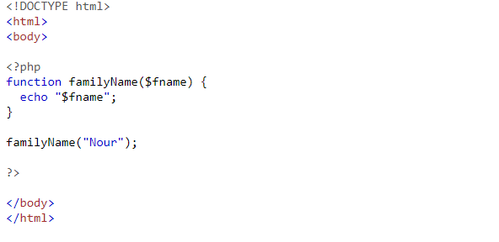

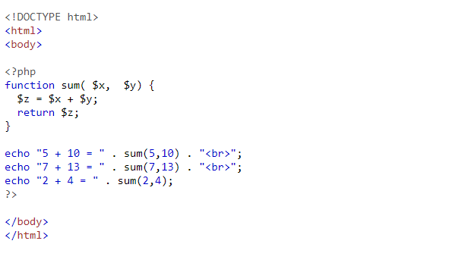

**Arrays:**

* *Indexed arrays:*

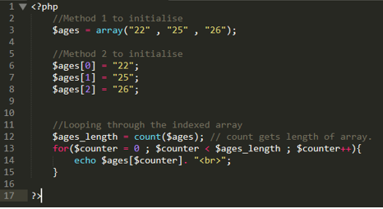

* *Associative array :*

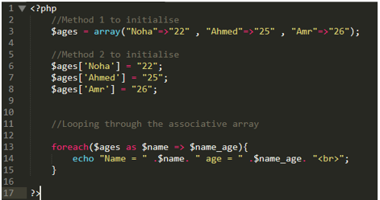

* $GLOBALS

PHP stores all global variables in an array called GLOBALS. To access a variable from globals, you write the variable name in the index:

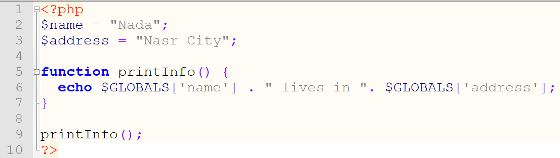

Exercises:

1. Write a function to sort an array.
   * Example





1. Write a function to check whether a number is prime or not.
   * Note: A prime number (or a prime) is a natural number greater than 1 that has no positive divisors other than 1 and itself
   * Example 1





* + Example 2





1. Write a PHP function to reverse the digits of an integer.
   * Example:



1. Write a PHP program to find the majority element in an array.
   * Example : array(1, 2, 3, 4, 5, 5, 5, 5, 5, 5, 6)

Output: 5

1. Write a PHP function to find the length of the last word in a string.
   * Example:

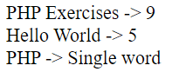

1. Write a PHP function to check whether an integer is the power of another integer.
   * Example:

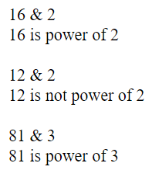

1. Write a PHP code to remove comma(s) from the following numeric string.
   * Example: '2,543.12'

Output: 2543.12

1. Write a PHP function to check whether the sequence of numbers 1, 2, 3 appears in a given array of integers somewhere.
2. Write a PHP function to check a specified number is present in a given array of integers.
3. Write a PHP function to check which number nearest to the value 100 among two given integers. Return 0 if the two numbers are equal.
   * Example

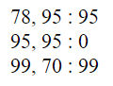

1. Write a PHP program to create a new string which is 4 copies of the 2 front characters of a given string. If the given string length is less than 2 return the original string.
   * Example

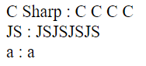

1. Write a PHP program to exchange the first and last characters in a given string and return the new string.
   * Example:

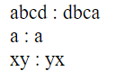

1. Write a PHP function to check two given integers and return true if one of them is 30 or if their sum is 30.
   * Example

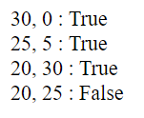

1. Write a PHP program to compute the sum of the two given integer values. If the two values are the same, then returns triple their sum.
   * Example

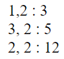

1. Create a script to construct the following pattern, using nested for loop.
2. 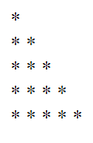
3. Create a script to construct the following pattern, using a nested for loop.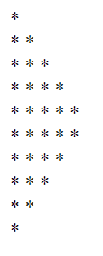
4. $color = array('white', 'green', 'red'')

Write a PHP code which will display the colors in the following way :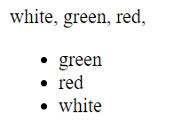

1. Write a PHP program to print out the multiplication table upto 6*6.

1 2 3 4 5 6

2 4 6 8 10 12

3 6 9 12 15 18

4 8 12 16 20 24

5 10 15 20 25 30

6 12 18 24 30 36

1. Write a PHP function to test if a given string occurs at the end of another given string.
   * Example

